International Symposium on Geomorphology - 2024 (UJES 2024)
POSTER PREPARATION GUIDE
- Poster size should be 90 cm (horizontal) x 120 cm (vertical) and the posters should be in one piece.
- 2 cm space should be left from the top, bottom, right and left sides of the poster page.
- The upper right corner of the poster should contain the name and logo of the Symposium.
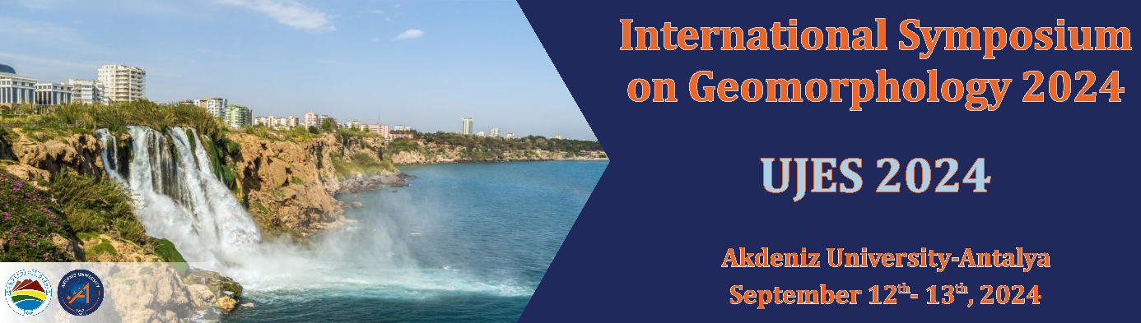
- All letters in the poster should be given using a writing style that is easy to read.
- Amasis MT Pro font should be used in the poster. The title of the poster must be written in 60 pt and bold, and care should be taken not to exceed two lines of heading.
- The letters should be used for author names and contact addresses at 30 pt and bold, 16-18 pt for other sections, and the author's name should be underlined.
- It should be preferred that the text should be presented in two columns, with occasional shapes.
- Headings of the sections in the text must be written in 24 pt and bold.
- Posters; Input, method, findings, results and discussion.
- At the end of the poster, the smaller characters and the sources must be indicated in the index.
- There is no color limitation in poster preparation, but emphasis should be given to using colored figures and photographs to increase visibility.
- In shapes, the appropriate size characters should be used to make the characters easily readable, and the same characters should be preferred in all shapes.
- Shapes should be given in sizes that are easily visible from a distance.
POSTER PRESENTATION RULES
- Posters will hang numbered panels to be determined by the Symposium Organizing Committee.
- Regarding the poster hanging, the members of the Symposium Organizing Committee will help poster holders.
- Poster holders will be at the beginning of their posters at the time and hours indicated in the schedule and will give information about their work.

